# **VRTS3 Distributed System Demo Board**

# **Description**

The VRTS3 demonstration board is a self-contained board designed to support a wide range of typical distributed system measurements. Input power is provided via a USB port using a typic al USB-A to USB-B cable. No additional equipment is required for this board other than the measurement instruments.

# **Demonstration circuits**

The board contains eight individual circuit sections as identified in Table 1. These circuits are typical in most distributed systems providing an excellent test bed for demonstrating non-invasive, in-system measurement, optimization, and troubleshooting techniques.

Table 1 Circuit Sections on the VRTS3 Board

|  |  |
| --- | --- |
| **SECTION** | **FUNCTION** |
| POL | 5V USB input to 3.3V 2.8MHz switching regulator |
| REF03 | 2.5V low noise voltage reference |
| OPAMP | 245MHz Bandwidth unity gain opamp buffer |
| LDO | LD1086 voltage regulator 5V USB input to 3.3V output |
| CLOCKS/BUFFERS | 10MHz and 125MHz clocks |
| CALIBRATION | Short-Open-Load and 1 Ohm calibration ports |
| PLANES & CAPS | Parallel tantalum and ceramic capacitor on a small PCB plane |
| MICROSTRIPS | 50Ω microstrips with precision aberrations - one with a ground void |

The USB connection provides +5V voltage for the POL, REF03, and LDO. The output of the LDO or POL provides power to the 10MHz and 125 MHz clocks, depending on the position of the SEL1 switch.

The REF03 voltage reference provides a 2.5V output voltage to the non-inverting input of the unity gain opamp. The REF03 output can be loaded with two different capacitors (C102 and C103) using the S101 switch. The capacitors are used to demonstrate the effects that output capacitance has on the stability of the REF03.

The CLC1007 opamp input is the 2.5V output voltage of the REF03. The opamp operates at unity gain. The opamp is powered as a single rail using the +5V input as the positive supply voltage.

The CAL section of the VRTS3 port provides convenient OPEN, SHORT, and LOAD calibrators for use with a 1-port probe. The calibration is important to ensure accurate measurements on VNAs. A 1 Ohm calibrator resistor is also provided for use with a 2-port probe.

The LMR10515Y POL regulator is powered by the +5V USB input voltage. The feedback loop can be opened and closed using the top switch of S1. The bottom switch of S1 can be used to change the output voltage between 2.5V and 3.3V. There are three output resistors (R5, R6, R7) that can be added to the output using the S2 switch to increase the output current. An input damping resistor (R2) can be added at the input using the S2 switch. The POL is able to power the clocks and buffers if the SEL1 switch is in the left position.

The LDO section includes an LT1086 that is powered by the post-filter 5V input and outputs 3.3V. The S301 switches control which output capacitors (C301, C302, C303, and C410) are present at the load. The LDO is able to power the clocks and buffers if the SEL2 switch is in the right position.

The planes and caps section contains a 470uF tantalum capacitor (C601) in parallel with a 0.1uF ceramic capacitor (C602).

The Clocks and Buffers section contains one 125MHz clock and two 10MHz clocks, along with buffers for each clock. The 125MHz clock output is connected to one NC7SZ04 inverter (U401). The 10MHz clock output is connected to two NC7SZ04 inverters (U402, U403) in parallel. A 15uF damping capacitor (C410) can be connected to U401 by using the S402 switch. The EMI probe can be used to observe the various frequencies of the clocks.

# **Supported Measurements**

|  |  |
| --- | --- |
| **TEST** | **SIGNAL INJECTORS NEEDED** |
| 1 Port Impedance | [DC Block](https://www.picotest.com/products_PDN_Probe.html) |
| Output Impedance | See Impedance Table 2 |
| Bode Plot | [J2100A](https://www.picotest.com/products_J2100A.html) or [J2101A](https://www.picotest.com/products_J2101A.html) |
| Non-invasive Stability | See Impedance Table 2 |
| Switching Frequency |  |
| Switch Rise Time |  |
| Duty Cycle Jitter |  |
| Noise | [DC Block](https://www.picotest.com/products_PDN_Probe.html), [1 Port Probe](https://www.picotest.com/products_PDN_Probe.html), [Preamp](https://www.picotest.com/products_J2180A.html) |
| PSRR | [DC Block](https://www.picotest.com/products_PDN_Probe.html), [J2120A](https://www.picotest.com/products_J2120A.html), or [J2111A](https://www.picotest.com/products_J2111A.html) |
| Step Load Response | [J2111A](https://www.picotest.com/products_J2111A.html) or [J2112A](https://www.picotest.com/products_J2112A.html) |
| Clock Jitter |  |
| Clock Rise Time |  |
| Jitter Sensitivity | [DC Block](https://www.picotest.com/products_PDN_Probe.html) |
| Power Supply Impedance | See Impedance Table 2 |
| Crosstalk |  |
| Clock Buffer PDN Noise | [DC Block](https://www.picotest.com/products_PDN_Probe.html) |
| Clock Buffer Impedance | See Impedance Table 2 |
| Parallel Capacitor resonance | [1 Port Probe](https://www.picotest.com/products_PDN_Probe.html) |
| Plane Impedance | [1 Port Probe](https://www.picotest.com/products_PDN_Probe.html) |
| Velocity Factor and Er |  |
| Trace Impedance |  |
| Impedance of Broken Ground |  |
| 2 port Shunt Thru Impedance | [J2120A](https://www.picotest.com/products_J2120A.html), [2 Port Probe](https://www.picotest.com/products_PDN_Probe.html), [DC Block](https://www.picotest.com/products_PDN_Probe.html) |
| Ripple | [DC Block](https://www.picotest.com/products_PDN_Probe.html), [Preamp](https://www.picotest.com/products_J2180A.html) |
| EMI | [Near Field Probes](https://www.picotest.com/products_EMC_Probes.html) |

Table 2 Picotest Product Applicability Impedance Matrix

|  |  |  |  |  |  |  |  |
| --- | --- | --- | --- | --- | --- | --- | --- |
| **Measurement** | [PDN Probes](https://www.picotest.com/products_PDN_Probe.html) | [Current Injector](https://www.picotest.com/products_J2111A.html) | [Pre-amplifier](https://www.picotest.com/products_J2180A.html) | [DC Blocker](https://www.picotest.com/products_J2130A.html) | [Current Probe](https://www.picotest.com/products_PEM_Probe.html) | [Common Mode Transformer](https://www.picotest.com/products_J2102A.html) | [Impedance Fixture](https://www.picotest.com/products_OL000153.html) |
|
| **1-port reflection 0.5Ω-2.5kΩ** | **X** |  |  |  |  |  |  |
|
| **2-port shunt thru 25uΩ-25Ω** | **X** |  | **X** |  |  | **X** |  |
|
| **2-port series thru 25Ω-1MΩ** | **X** |  |  |  |  |  |  |
|
| **3-port voltage/current 1mΩ-2kΩ** | **X** | **X** | **X** |  | **X** | **X** |  |
|
| **Impedance adapters 0.1 Ω-400kΩ** |  |  |  |  |  |  | **X** |
|
| **1-port TDR 10mΩ-1kΩ** | **X** |  |  | **X** |  |  |  |
|
| **2-port TDT 10mΩ-1kΩ** | **X** |  |  | **X** |  | **X** |  |
|
| **Transient extraction mΩ-1kΩ** | **X** | **X** | **X** | **X** |  | **X** |  |
|

Switches are used to allow various configuration settings for many of the circuits. A summary of the switches is included in Table 2.

Table 3 Switch Functions

|  |  |  |  |  |  |
| --- | --- | --- | --- | --- | --- |
| **POSITION** | **ON** | | **OFF** | | |
| **S1** | | | | | |
| 1 | 4.99Ω Bode plot injection resistor | | Open feedback for use with the J2110A Solid State Injector | | |
| 2 | Sets POL output to 2.5V | | Sets POL Output to 3.3V | | |
| **S2** | | | | | |
| 1 | 0.51Ω filter damping resistor | | 5.41Ω filter damping resistor | | |
| 2 | DISABLE POL regulator | | ENABLE POL regulator | | |
| 3 | Add additional 100mA load to POL | |  | | |
| 4 | Add additional 100mA load to POL | |  | | |
| 5 | Add additional 100mA load to POL | |  | | |
| **S101** | | | | | |
| 1 | 0.1uF ceramic capacitor | |  | | |
| 2 | 0.33uF ceramic capacitor | |  | | |
| **S201** | | | | | |
| 1 | 5.1pF NPO capacitor | |  | | |
| 2 | 10pF NPO capacitor | |  | | |
| **S301** | | | | | |
| 1 | 22uF ceramic capacitor | |  | | |
| 2 | 100uF 30mOhm ESR tantalum capacitor | |  | | |
| 3 | 2.2uF 0.5 Ohm ESR tantalum capacitor | |  | | |
| 4 | 15uF 0.4 Ohm ESR tantalum capacitor | |  | | |
| **S401** | | | | | |
| 1 | DISABLE 125MHZ clock | | ENABLE 125MHZ clock | | |
| 2 | DISABLE 10MHz clock | | ENABLE 10MHz clock | | |
| **S402** | | | | | |
| 1 | 15uF tantalum damping capacitor U401 | |  | | |
| **SEL1** | | | | |
| LEFT | | CENTER | | RIGHT |
| 125MHz clock POL powered | | 125MHz clock unpowered | | 125MHz clock LDO powered |

The demo board is shown pictorially in Figure 1.

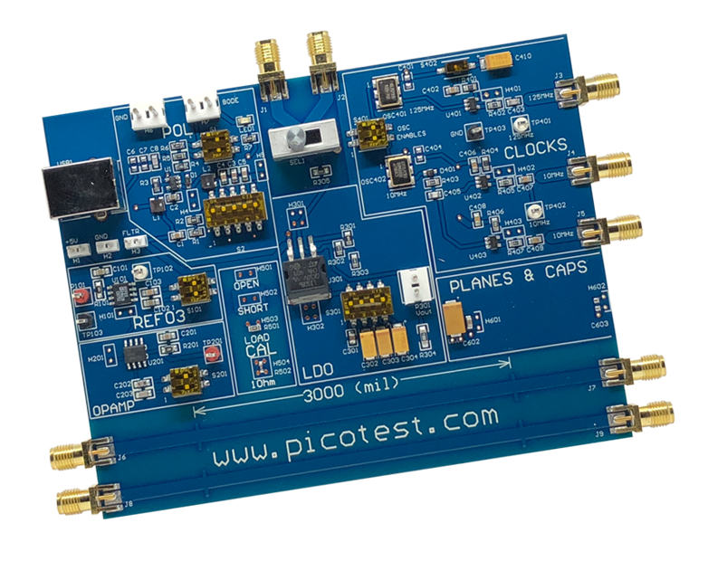

Figure 1 Demonstration Board.

# **Powering the Board**

Step 1: Make sure Switch S1 is set to the ‘ON’ position.

Step 2: Plug one end of the USB cable into the USB port on the VRTS board. Plug the other end of the USB cable into any USB power supply or computer USB port.

# **Schematics**

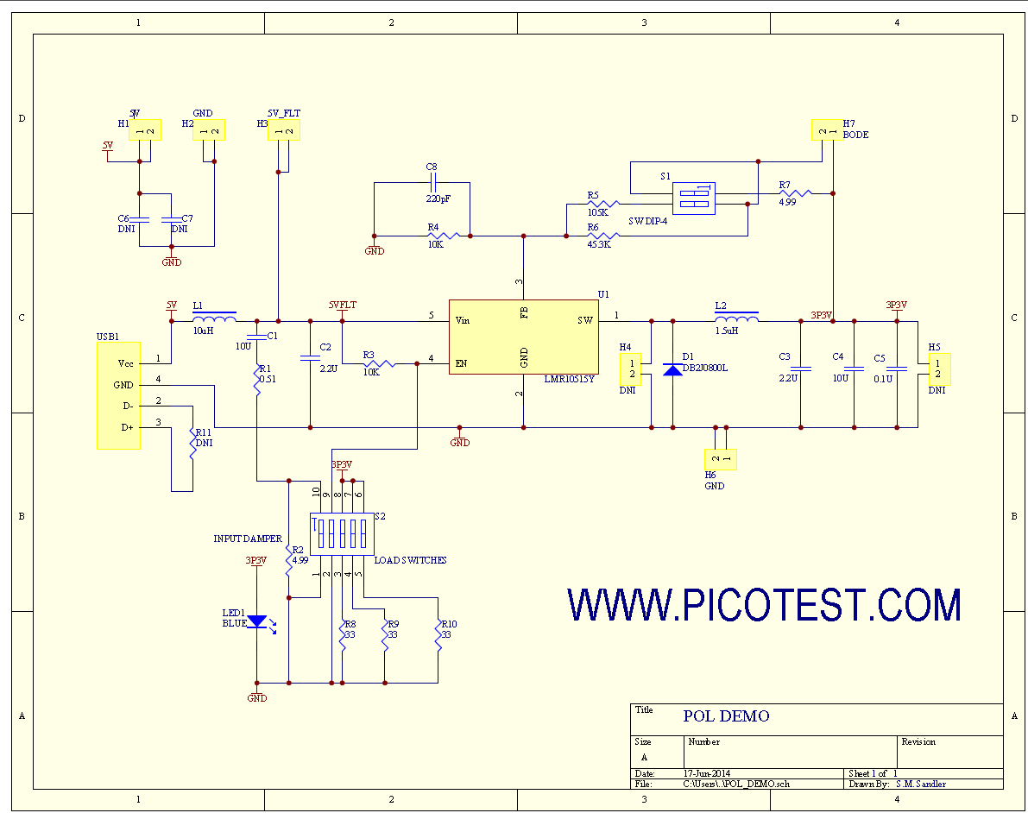

Figure 2 Schematic, POL Circuit.

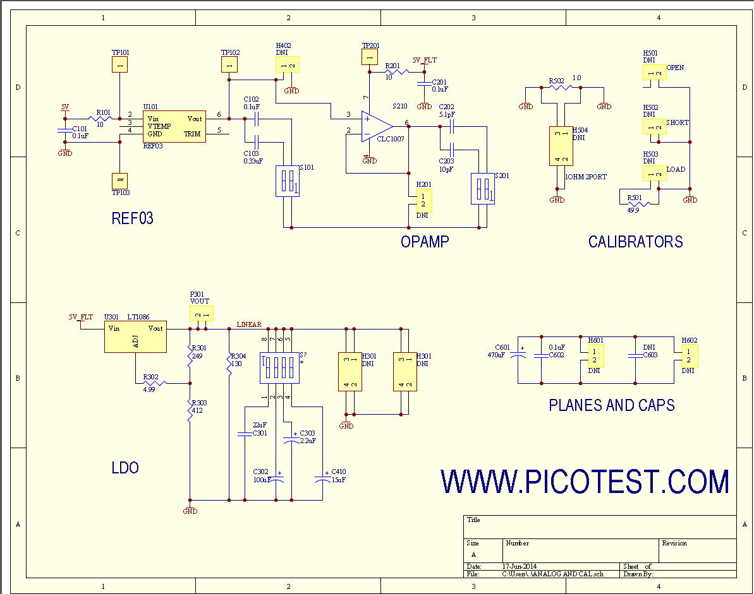

Figure 3 Schematic, Analog and Planes & Capacitors.

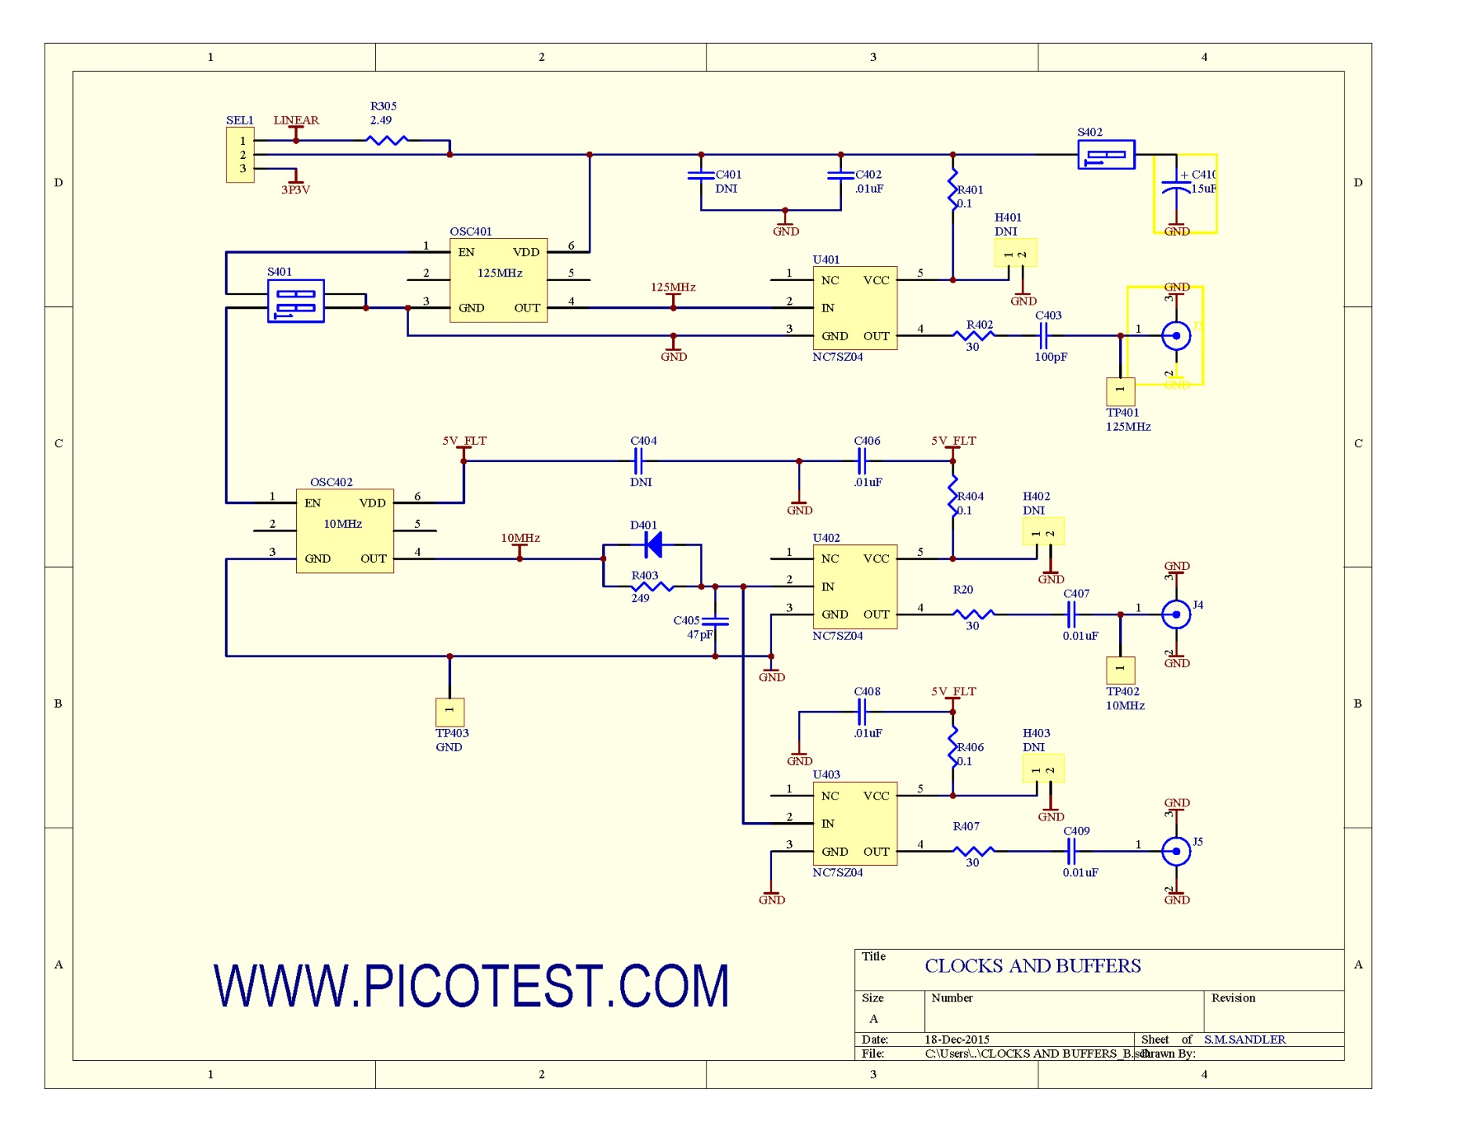

SEL1 Left

From POL

SEL1 Right

From LDO

J2

J1

J5

J4

J3

Figure 4 Schematic, Clocks and buffers

# **BOM**

Table 4 Bill of Materials

| **Designators** | **Comment** | **Description** | **QTY** |
| --- | --- | --- | --- |
| C1,C4 | 10uF | Capacitor, Ceramic X7R | 2 |
| C2,C3 | 2.2uF | Capacitor, Ceramic X7R | 2 |
| C5 | 0.1uF | Capacitor, Ceramic X7R | 1 |
| C6 | DNI | NOT INSTALLED | 0 |
| C7 | DNI | NOT INSTALLED | 0 |
| C8 | 220pF | 220pF COG | 1 |
| D1 | DB2J0800L | Diode, Schottky, 20V low Capacitance | 1 |
| H1,H2,H3 |  | 2 pin male header, unshrouded 100mil pitch | 3 |
| H4,H5 |  | PADS ONLY NO PART INSTALLED | 0 |
| H6,H7 |  | 2 pin male header, unshrouded 156mil pitch | 2 |
| J1-J9 |  | SMA edge launch connector | 9 |
| L1 | 10uH | Inductor, 10uH 630mA High Q Ferrite | 1 |
| L2 | 1.5uH | Inductor, 1.5uH 1.5A High Q Ferrite | 1 |
| LED1 | BLUE | Led 3.3V 20mA, Blue | 1 |
| R1 | 0.51 | Resistor, Thick Film 100ppm 1% 0.51 Ohm | 1 |
| R2, R7 | 4.99 | Resistor, Thick Film 100ppm 1% 4.99 Ohm | 2 |
| R3, R4 | 10K | Resistor, Thick Film 100ppm 1% 10 kOhm | 2 |
| R5 | 105K | Resistor, Thick Film 100ppm 1% 105 kOhm | 1 |
| R6 | 45.3K | Resistor, Thick Film 100ppm 1% 45.3 kOhm | 1 |
| R8-10 | 33 | Resistor, Thick Film 100ppm 1% 33 Ohm 1W | 3 |
| R11 | DNI | NOT INSTALLED | 0 |
| S1 | SPST | Dip Switch, 2-Pos SPST 100mA washable | 2 |
| S2 | SPST | Dip Switch, 5-Pos SPST 100mA washable | 1 |
| SEL1 | SPDT | SWITCH MINIATURE SLIDE SPDT | 1 |
| U1 | LMR10515Y | IC REG SW STEP DOWN 1.5A SOT23-5 | 1 |
| USB1 |  | CONN USB TYPE B R/A BLACK | 1 |
| Rubber Bumpers |  | BUMPON HEMISPHERE .44X.20 BLACK | 4 |
| C101,C102 | 0.1uF | Capacitor, Ceramic X7R | 2 |
| C103 | 0.33uF | Capacitor, Ceramic X7R | 1 |
| H101 | DNI | NOT INSTALLED | 0 |
| R101 | 10 | Resistor, Thick Film 100ppm 1% 10 Ohm 0.125W | 1 |
| S101 | SPST | Dip Switch, 2-Pos SPST 100mA washable | 2 |
| TP101 | RED | TESTPOINT | 1 |
| TP102 | WHITE | TESTPOINT | 1 |
| TP103 | BLACK | TESTPOINT | 1 |
| U101 | REF03 | Voltage Reference Precision 2.5V Series | 1 |
| C201 | 0.1uF | Capacitor, Ceramic X7R | 2 |
| C202 | 5.1pF | Capacitor, Ceramic COG | 1 |
| C203 | 10pF | Capacitor, Ceramic COG | 1 |
| H201 | DNI | NOT INSTALLED |  |
| R201 | 10 | Resistor, Thick Film 100ppm 1% 10 Ohm 0.125W | 1 |
| S201 | SW DIP-4 | Dip Switch, 2-Pos SPST 100mA washable | 1 |
| TP201 | RED | TESTPOINT | 1 |
| U201 | CLC1007 | OPAMP, 245MHz, Voltage Feedback | 1 |
| C301 | 22uF | CERAMIC 22uF 6.3V X5R | 1 |
| C302 | 100uF | TANTALUM 100uF 6.3V 30mOhm | 1 |
| C303 | 2.2uF | TANTALUM 2.2uF 25V 0.5 Ohm | 1 |
| C304 | 15uF | TANTALUM 15uF 20V 0.4 Ohm | 1 |
| H301 | DNI | PADS ONLY NO PART INSTALLED | 0 |
| H302 | DNI | PADS ONLY NO PART INSTALLED | 0 |
| P301 | Comment | 2 pin male header, unshrouded 156mil pitch | 1 |
| R301 | 4.99 | Resistor, Thick Film 100ppm 1% 4.99 Ohm | 2 |
| R302 | 249 | Resistor, Thick Film 100ppm 1% 249 Ohm | 1 |
| R303 | 412 | Resistor, Thick Film 100ppm 1% 412 Ohm | 1 |
| R304 | 130 | Resistor, Thick Film 100ppm 1% 130 Ohm | 1 |
| R305 | 2.49 | Resistor, Thick Film 100ppm 1% 2.49 Ohm | 1 |
| S301 | SPST | Dip Switch, 4-Pos SPST 100mA washable | 1 |
| U301 alt | LD1086 | Voltage Regulator, Adjustable | 1 |
| C401 | DNI | NOT INSTALLED | 0 |
| C402, C406-C409 | .01uF | Capacitor, Ceramic X7R | 5 |
| C403 | 100pF | Capacitor, Ceramic COG | 1 |
| C404 | DNI | NOT INSTALLED | 0 |
| C405 | 47pF | Capacitor, Ceramic COG | 1 |
| C410 | 15uF | TANTALUM 15uF 20V 0.4 Ohm | 1 |
| D401 | BAS16 | DIODE 100V 250MA SC-90 | 1 |
| H401,H402,H403 | DNI | PADS ONLY NO PART INSTALLED | 0 |
| OSC401 | 125MHz | OSC 125.0000 MHZ 3.3V HCMOS SMT | 1 |
| OSC402 | 10MHz | OSC 10.000 MHZ 5.0V SMD | 1 |
| R401,R404,R406 | 0.1 | Resistor metal foil | 3 |
| R402,R405,R407 | 30 | Resistor, Thick Film 100ppm 1% 30 Ohm | 3 |
| R403 | 249 | Resistor, Thick Film 100ppm 1% 249 Ohm | 1 |
| S401 | SPST | Dip Switch, 2-Pos SPST 100mA washable | 2 |
| S402 | SPST | Dip Switch, 1-Pos SPST 100mA washable | 1 |
| TP401,TP402 | WHITE | TESTPOINT | 1 |
| TP403 | BLACK | TESTPOINT | 1 |
| U401-U403 | NC7SZ04 | single gate high speed inverter | 3 |
| H501,H502,H503 | DNI | NOT INSTALLED | 0 |
| H504 | DNI | NOT INSTALLED | 0 |
| R501 | 49.9 | Resistor, Thick Film 100ppm 1% 49.9 Ohm | 1 |
| R502 | 1.00 | Resistor, Thick Film 100ppm 1% 1.0 Ohm | 1 |
| C601 | 470uF | TANTALUM 470uF 6.3V 45mOhm | 1 |
| C602 | 0.1uF | Capacitor, Ceramic X7R | 1 |
| C603 | DNI | Capacitor, Ceramic X7R |  |
| H601,H602 | DNI | NOT INSTALLED |  |

# **Safety Information**

Caution: To avoid equipment damage and/or severe injuries or death ensure that the absolute maximum ratings defined in this manual are observed at all times.

|  |  |
| --- | --- |
| **Characteristic** | **Rating** |
| Absolute Maximum Input Voltage | 5.25V |
| Maximum Output Voltage | +/-5V |
| Maximum Input Current | 500mA |
| Temperature range | 0-50°C |
| Absolute Maximum Voltage | <50 VAC and 75VDC |